Practical activity: Cracking
Practical Guide – Cracking

Aim: To simulate industrial process of producing smaller alkanes for petrol by cracking large hydrocarbons
Notes and guidance
You may wish to have students collect the equipment for this themselves from communal trays at the front of the lab. This will help them to develop their skills of equipment recognition and organisation. However, if this is impractical, ask your technician colleagues if they are able to set up individual sets at student workstations.

Consult CLEAPSS Hazcards for handling/disposal information. This practical can be difficult and hazardous, consider doing this as a demonstration as opposed to a class practical if students cannot be trusted.

The Bunsen valve at the end of the delivery tubing helps to prevent suck-back. If it looks like suck-back may occur, remove the equipment from the water.
Risk Assessment Notes
A risk assessment must be completed for this practical. The risk assessment should be specific to the class involved and written only by the teaching member of staff. For more guidance refer to CLEAPSS. It is good practice for students to wear safety spectacles during all class practicals and demos.

Consult CLEAPSS Hazcards for handling/disposal information. This practical can be difficult and hazardous, consider doing this as a demonstration as opposed to a class practical if students cannot be trusted.

The Bunsen valve at the end of the delivery tubing helps to prevent suck-back. If it looks like suck-back may occur, remove the equipment from the water.

CLEAPSS Hazcards: Medicinal (liquid paraffin)HC045b, Bromine Water HC015b, Mineral Wool HC086A, Acidified Potassium Manganate(VII) solution HC081 and Recipe Book RB073.
Equipment Per Group | Equipment Setup  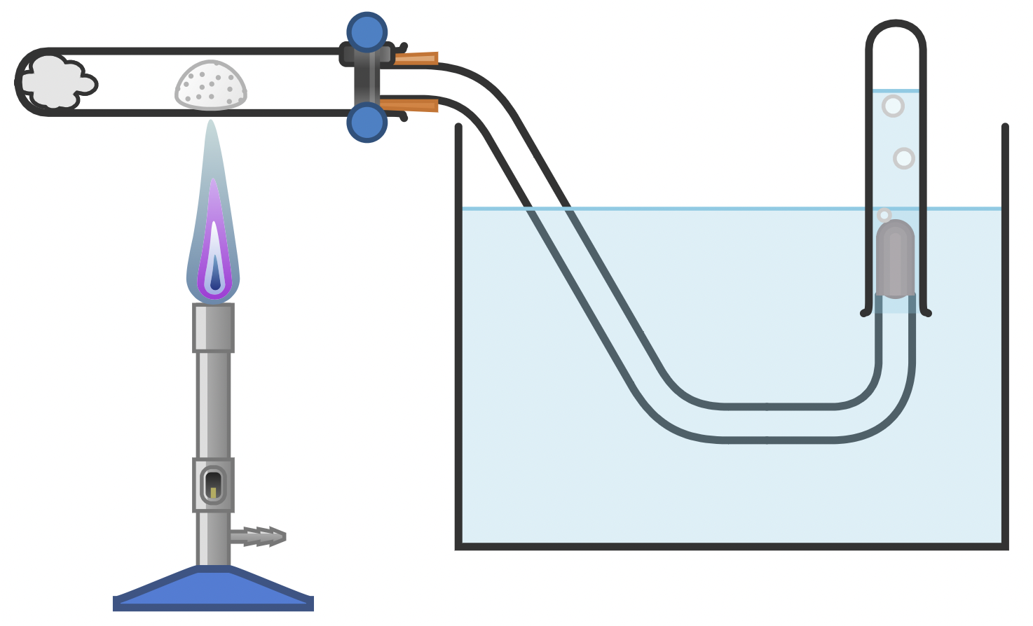
Apparatus:
- mineral wool
- boiling tubes
- test tubes
- one-hole bung
- delivery tube with Bunsen valve (to prevent suck-back)
- water trough
- Bunsen burner
- heat proof mat
- clamp stand
- pipette

Chemicals:
- medicinal (not fuel) liquid paraffin
- aluminium oxide powder or porous pot or pumice stone fragments (catalyst)
- 0.01 M bromine water
- acidified potassium manganate(VII) solution
Method |  | Questions To Ask Students During The Practical
- Place mineral wool in the bottom of a boiling tube and soak it with approx. 2 ml liquid paraffin. Ensure the paraffin does not drip out of the wool when the boiling tube is angled horizontally.  - Angle the tube horizontally and place some porous pot fragments in the centre, then clamp the boiling tube at the open end.  - Insert a bung and delivery tubing into the boiling tube with a Bunsen valve into an upturned test tube full of water inside a water trough at the other end of the delivery tubing (as per diagram).  - Heat the porous pot catalyst in the middle of the tube for a few minutes until you observe a dull red heat. Do not heat the rubber bung as this can melt. Keep the catalyst hot by flicking the flame on and off for a few seconds in order to vaporise liquid paraffin.  - When a steady stream of gas bubbles is being produced, fill four test tubes, seal with bungs, and place these in a test tube rack.  - The collected gas can be tested for appearance, smell, flammability, and with bromine water/acidified potassium(VII) manganate solution. |  | - How can we safely smell the collected gas? (Hold the test tube somewhat away from our face and waft the smell towards us with one hand. Try to fully breathe in before smelling the gas to avoid inhaling.)  - Describe the smell of the collected gas. (Smell is distinct from the smell of liquid paraffin.)  - Is the collected gas flammable? (Yes, it burns with a yellow flame.)  - What effect does the collected gas have on bromine water solution? (It decolourises the solution.)  - What does the collected gas having this effect on the bromine water solution indicate about its chemistry? (This indicates that the hydrocarbon is unsaturated – contains double C=C bonds.)  - What effect does the collected gas have on acidified potassium manganate(VII) solution? (It decolourises the solution.)  - What does the collected gas have this effect on the acidified potassium manganate(VII) solution indicate about its chemistry? (This indicates that the hydrocarbon oxidises the solution.)
The Bunsen Valve
The Bunsen valve at the end of the delivery tubing helps to prevent suck-back. If it looks like suck-back may occur, remove the equipment from the water.

This valve can be easily constructed thus:

RUBBER TUBING



GLASS ROD PLUG

END OF DELIVERY TUBE
CUT SLIT WITH SCALPEL

Alternative Methods/Computer Simulations |  | Clearing up
This practical can be difficult and hazardous, consider doing this as a demonstration as opposed to a class practical if students cannot be trusted. |  | It is important that equipment is returned to the prep room in good order. If safe to do so, rinse used equipment and put it in the used equipment tray. If the trays arrived on a trolley, students must return all trays and equipment to that trolley. Anything dirty needs to be placed into a separate container for washing up. Never put dirty equipment back into a tray with clean equipment.  Do not pour chemicals down the sink. Consult with your science technician colleague about the best way to leave liquids for collection at the end of the lesson.
Technician Notes
Ensure the solutions you provide are free from contamination and the equipment is as clean as possible.

Discuss this practical with the class teacher ahead of time. Ensure they have considered the risks of this practical and are confident with the techniques used. If necessary, provide them with the CLEAPSS hazcards (identified in the risk section section above) so they are comfortable with the chemicals to be used and how to use and dispose of them safely.

The boiling tube used for this practical should be a hard and thick borosilicate glass 150 mm x 25 mm.

Ensure the boiling tubes and bungs have a good and tight fit.

